Supplementary Material S3

Rediscovery of Stomaphis radicicola Hille Ris Lambers, 1947 (Hemiptera, Aphididae, Lachninae) in Europe – potential past and future distribution of large but cryptic, arbicolous aphid species

Thomas Sobczyk, Bernhard Seifert, Agnieszka Bugaj-Nawrocka, Łukasz Depa

Supplementary Material S3: MaxEnt model outputs

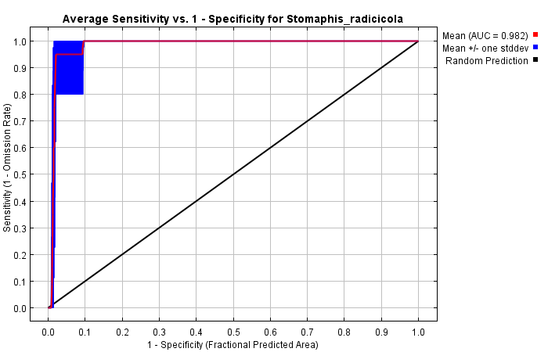
Figure S3.1. The receiver operating characteristic (ROC) curve generated in MaxEnt, showing an average of 10 repetitions of the model for Stomaphis radicicola.

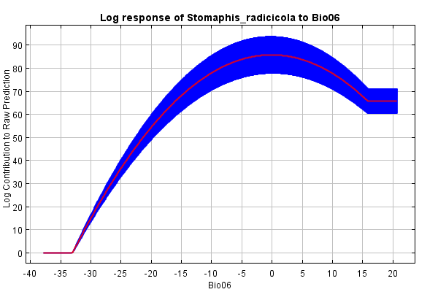

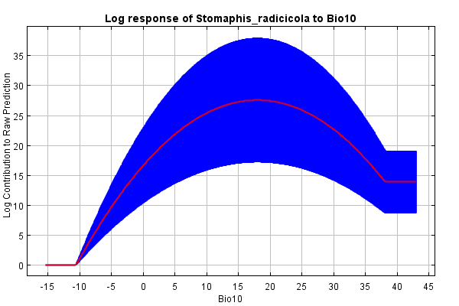

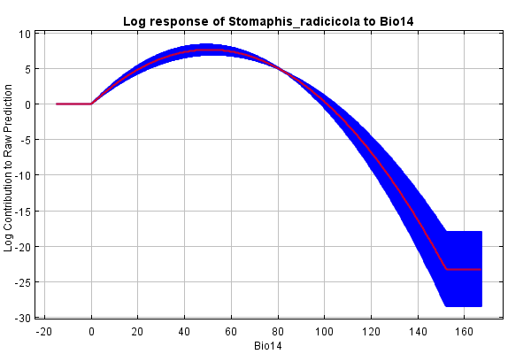

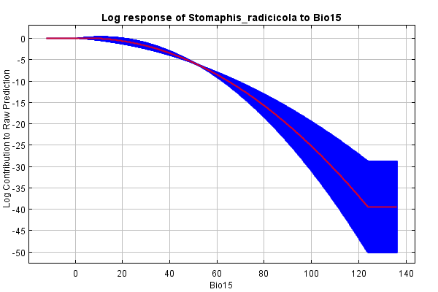

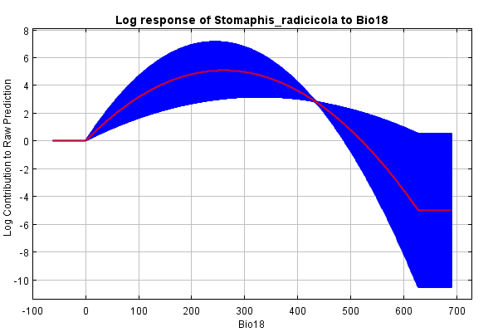

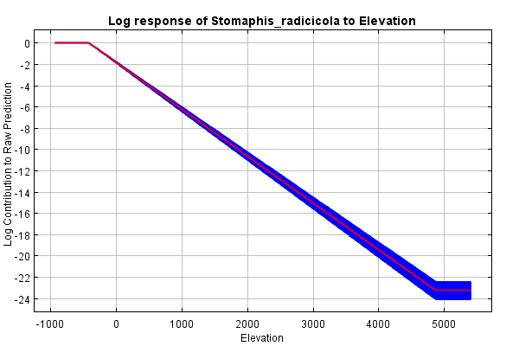
Figure S3.2. Results of response curves for selected variables for Stomaphis radicicola. The curves show the mean response of the 10 replicate MaxEnt runs (red) and the mean +/- one standard deviation (blue, two shades for categorical variables).

